# Physical Layer

## Outline

* Circuits and Data Flow
* Multiplexing
* Media
* Digital Transmission of Digital Data
* Analog Transmission of Digital Data
* Digital Transmission of Analog Data
* Implications for Management

## Physical Layer: intro

* Layer 1 in the Internet model
* Focus on transmission over circuits
* 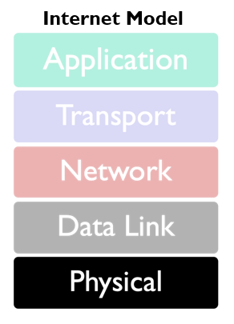Types of Circuits
  + **Physical circuits** connect devices & include wires
  + **Logical circuits** refer to the transmission characteristics of the circuit
* Physical and logical circuits may be the same or different. For example, in multiplexing, one physical wire may carry several logical circuits

## Types of Data Transmitted

* **Analog data**
  + Produced by telephones
  + Sound waves, which vary continuously over time, *analog*ous to one’s voice
  + Can take on any value in a wide range of possibilities
* 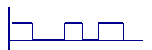**Digital data**
  + Produced by computers, in binary form
  + Information is represented as code in a series of ones and zeros
  + All digital data is either on or off, 0 or 1

## Types of Transmissions

* **Analog transmissions** 
  + Analog data transmitted in analog form
  + Examples of analog data being sent using analog transmissions are broadcast TV and radio
* **Digital transmissions**
  + Made of discrete square waves with a clear beginning and ending
  + Computer networks send digital data using digital transmissions
* **Data converted between analog and digital formats** 
  + Modem (modulator/demodulator): used when digital data is sent as an analog transmission
  + Codec (coder/decoder): used when analog data is sent via digital transmission

## Digital Transmission: Advantages

* **Produces fewer errors**
  + Easier to detect and correct errors, since transmitted data is binary (1s and 0s, only two distinct values)
  + A weak square wave can easily be propagated again in perfect form, allowing more crisp transmission than analog
* **Permits higher maximum transmission rates**
  + e.g., optical fiber designed for digital transmission
* **More efficient**
  + Possible to send more digital data through a given circuit, circuit can be “packed”
* **More secure**
  + Easier to encrypt digital bit stream
* **Simpler to integrate voice, video and data** 
  + Easier mix and match of voice, video, data on the same circuit, since all signals made up of 0’s and 1’s

## Digital Transmission: Disadvantages

* **More bandwidth requirement** 
  + requires more bandwidth, which is costly and limited.
* **Additional circuitry required for encoding and decoding**
* **Require Synchronization:** 
  + Digital transmissions require precise time synchronization between the clocks in transmitter and receiver.

## Circuits

* Circuit Configuration
  + **Point-to-Point** circuits include most wired connections today
  + **Multipoint** circuits are most commonly used in wireless today
* Shared circuits (multipoint) are less expensive

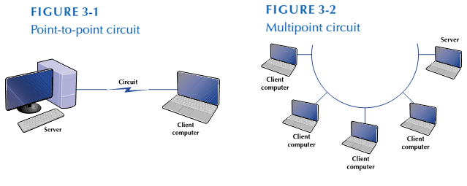

## Data Flow

* Simplex: data flows in **one direction**
* Half-duplex: data flows **both directions**, but only **one at a time**
* Full-duplex: data flows simultaneously in **both directions**

c03f003.eps

## Multiplexing

* Divide high-speed circuit into several slower (logical) circuits
* Main advantage is cost
* Categories of multiplexing
  + Frequency/Wavelength
  + Time

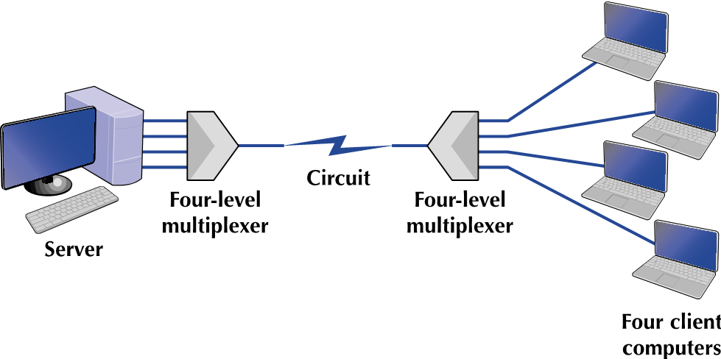

## Frequency Division Multiplexing (FDM)

* Makes a number of smaller channels from a larger frequency band by dividing the circuit “horizontally”
* **Guardbands** needed to separate channels in order to prevent interference between channels
* Unused frequency bands are wasted capacity (almost ½ in this example)

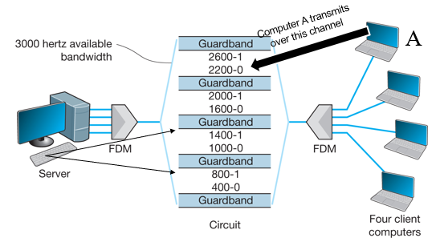

## Time Division Multiplexing

* TDM allows terminals to send data by taking turns
* Dividing the circuit “vertically”
* This example shows 4 terminals sharing a circuit, with each terminal sending one character at a time

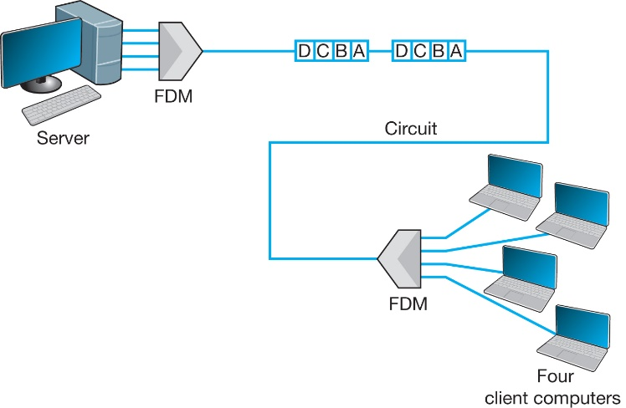

## Circuit switching: FDM versus TDM

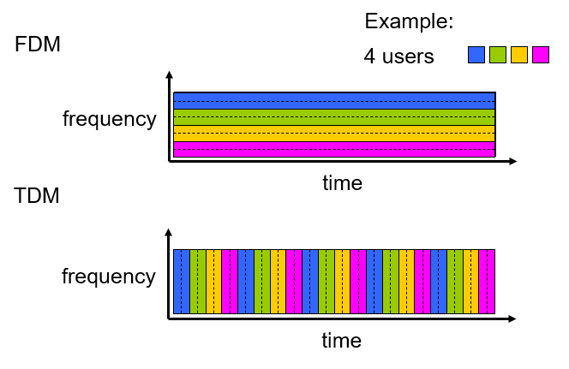

## Wavelength Division Multiplexing (WDM)

* A variant of FDM used in fiber optic circuits
* Makes use of multiple light wavelengths (colors) to divide circuit into channels
* Dense WDM can divide circuit into more than 100 channels per fiber each transmitting at 10 Gbps

## Media

* Physical matter used to carry voice or data transmissions
* **Guided media** – transmission flows along physical medium
* **Wireless (Radiated) media** - transmission flows through the air

## Guided Media

* **Twisted-pair (TP) cable**
  + Insulated pairs of wires bundled together
  + Wires twisted to reduce electromagnetic interference

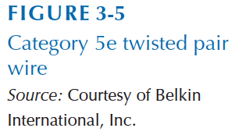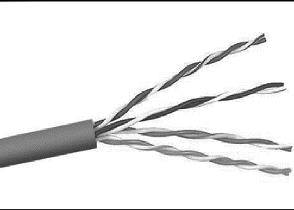

* + Some times use additional shielding (STP)
  + Commonly used for telephones, LANs
  + Characteristics
    - Price – inexpensive
    - Distance – typically up to 100m
    - Use - Telephones, LANs
* **Coax cable**
  + Has a single copper core, plus outer insulation, shielding, and inner insulation
  + Less prone to interference
  + Characteristics



* + - Price - inexpensive (but more costly than TP)
    - Distance - up to 2 km (1.2 miles)
    - Use: Cable TV / Internet
* **Fiber optic cable**
  + Optical core made of glass or plastic
  + Data transmitted using light from lasers or LEDs
  + Resistant to interference and corrosion
  + Extremely fast data rates
  + Characteristics
    - Price: Expensive
    - Distance: 500m – 100km
    - Use: Trunk line / Backbone, long distance circuits (e.g., undersea cables)

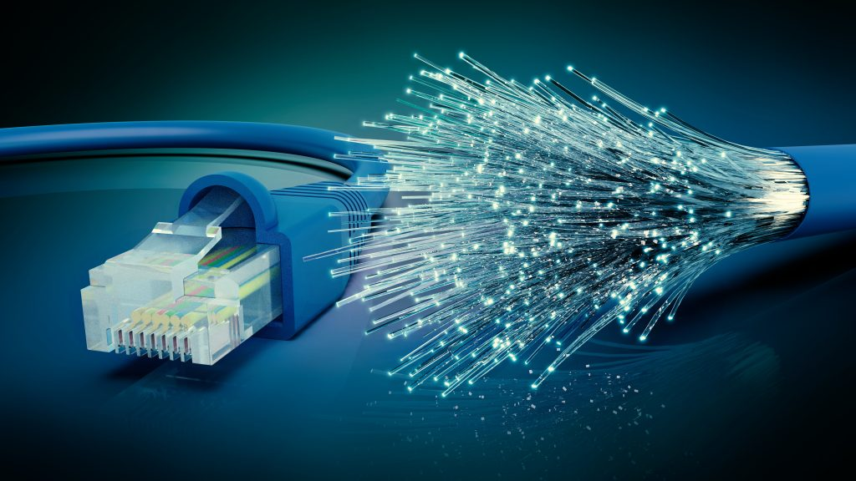

## Wireless Media

* Radio
  + Wireless transmission of electrical waves through air
  + Each device on network has a radio transceiver operating at a specific frequency range
  + Enables mobile network communication
  + Characteristics
    - Distance: depends on frequency and power
    - Use: Wireless LANs, cellular and cordless phones, baby monitors
* Microwave

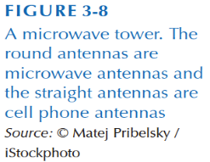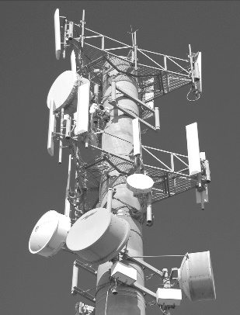

* + High-frequency radio communication
  + Requires line of sight which may require large antennas and towers
  + Affected by weather
  + Characteristics
    - Distance: ~60 km (due to curvature of earth
    - Use: Trunk line / Backbone, long distance
* Satellite
  + Special form of microwave communication
  + Long distance leads to propagation delays

## Media Selection

* Factors to consider in media selection
  + Type of network
  + Cost
  + Transmission distance
  + Security
  + Error rates
  + Transmission speeds

## Digital vs. Analog Data

* **Digital** transmission involves discrete binary values (i.e., 0 or 1)
* **Analog** transmission involves continuous waves

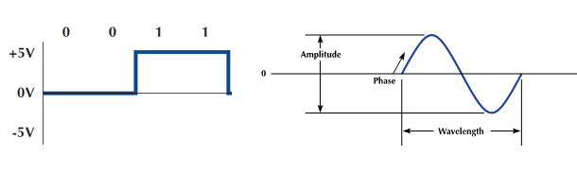

## c03f010.epsDigital Transmission of Digital Data

* Coding scheme needed to ensure sender and receiver understand messages (e.g., ASCII, Unicode, etc.)
* A character is represented by a group of bits
* Transmission modes
  + **Parallel:** multiple bits transmitted simultaneously

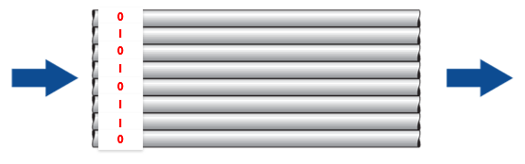

* + **Serial:** bits are transferred sequentially, one at a time

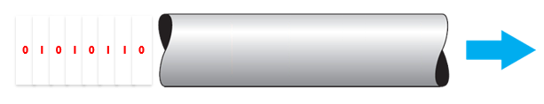

* Sender and receiver must agree upon:
  + Set of symbols
    - How bits are encoded as voltages or light pulses
    - e.g., +5V might be encodes as a “1”
* Symbol rate
  + How often symbols are sent
  + e.g., with a symbol sent at every clock cycle. 64 kilohertz (kHz) = 64,000 symbols/sec